**Project 2: White Paper Draft**

Mithil Patel

Bellevue University

DSC680-T302 Applied Data Science

Prof. Catherine Williams

May 4th, 2023

**Business Problem**

The text-based emotion recognition model is designed to identify people's emotions, attitudes, or sentiments toward a particular goal, such as an individual, an organization, a topic, or a product. With thousands of reviews on the company's website and social media, it can be cumbersome to peruse each review to understand the overall emotional state; therefore, text-based emotion recognition can help to address this problem by analyzing the emotional content of posts. Additionally, it can also solve online harassment and cyberbullying. According to a study by the Cyberbullying Research Center, approximately 30 percent of teens in the United States have experienced cyberbullying, and the prevalence of online harassment is on the rise. Text-based emotion recognition offers a more nuanced approach to evaluating online reviews and detecting and preventing online harassment by analyzing the emotional content of messages.

Sentiment analysis is a widely used method for gauging emotions, but it only scratches the surface by assessing a text's overall positive, negative, or neutral sentiment. On the other hand, emotion detection is a more specialized technique that can pinpoint specific emotions within a text. Many researchers have previously worked on emotion identification of facial and speech expressions; however, text-based emotion detection is underdeveloped as it is an uphill task due to missing cues such as tone or facial expressions in speech. Therefore, the project will focus on creating a model capable of detecting specific emotions based on text using optimal machine learning (ML) and deep learning (DL) algorithms.

**Background/History**

Text-based emotion recognition, aka sentiment analysis, uses natural language processing (NLP) and ML techniques to identify and extract emotional information from text data. The purpose of the model is to detect the writer's emotional state based on the words used to express themselves.

The earliest history of text-based emotion recognition can be traced back to the 1950s and 1960s when researchers were focused on algorithms development for parsing and analyzing natural language text, with emphasis on information retrieval and machine translation. However, researchers did not truly begin to explore NLP and ML techniques for sentiment analysis and text-based emotion recognition until the 1980s and 1990s. In 1987, Rosalind Picard proposed a computational model for recognizing emotions from facial expressions and other physiological signals.

With the rise of social media and the explosion of text data generated daily in recent years, text-based emotion recognition has gained significant importance and popularity in society. As a result, researchers have devoted considerable efforts to developing and refining algorithms and techniques for recognizing emotions in text. Text-based emotion recognition technology has significantly evolved with applications in a wide range of fields, such as social media, marketing, healthcare, and politics. Despite the numerous challenges and limitations, text-based emotion recognition undoubtedly holds the potential to offer valuable insights into the emotional state of individuals and groups and empower organizations to make more informed decisions based on these insights.

**Data Explanation (Data Prep/Data Dictionary/etc)**

To develop a machine learning model, a good dataset will be vital to accurate predictions. The text-based emotion recognition model will use datasets from ISEAR and WASSA. The International Survey on Emotion Antecedents and Reactions (ISEAR) dataset, which was created by psychologists who conducted surveys in 37 countries using text and emotional stimuli, includes data on 173 emotional experiences that have been categorized into seven types of emotions: sadness, fear, shame, joy, anger, surprise, and disgust. The WASSA-2017 dataset comprises a collection of tweets annotated with emotion labels, with each tweet accompanied by an emotion intensity score ranging from 0 to 1. However, to ensure consistency between the two datasets and achieve accurate model training, the project will utilize only text and emotion labels. This approach not only allows for a larger dataset, but also ensures commonality between the two datasets.

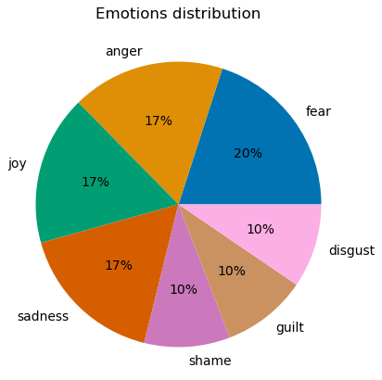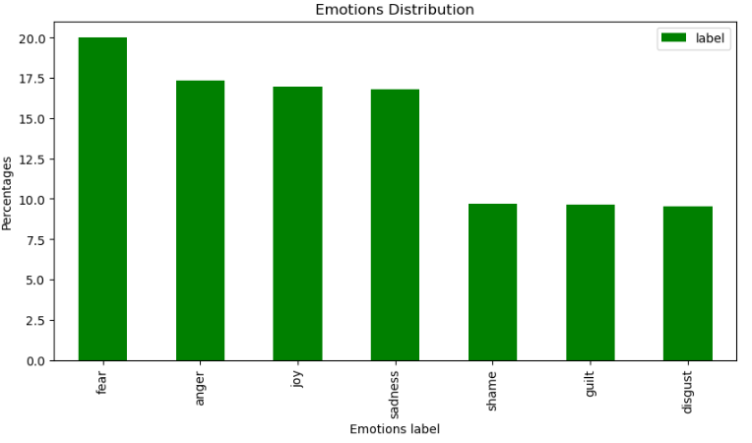**Fig 1:** A pie chart (left) and histogram (right) to show the distribution of emotions label present in the dataset.

During the data preparation process, a variety of data wrangling techniques were utilized to ensure that the trained model is efficient and consistent. We begin the process by changing the column names to match both datasets for merging. Once merged, a pie chart and histogram (shown above in Fig. 1) of the emotion label were created to gain insight into the distribution of the emotion. Since tweets often contain noisy and irrelevant information, such as hashtags, user mentions, URLs, and emojis, the dataset was cleaned to remove Twitter mentions, hyperlinks, special characters, punctuation, numbers, and stop words. After filtering extraneous information, the text was tokenized to split the sentences into individual words. Then, the tokenized text was lemmatized to convert words to their root form to reduce the number of unique words. Finally, word embedding was applied to the text to capture the meaning of words and their relationship to other words. The emotion labels were converted to numerical labels, as ML and DL algorithms require numerical data as input. The raw data set and final product are shown in Fig. 2 & 3 below.

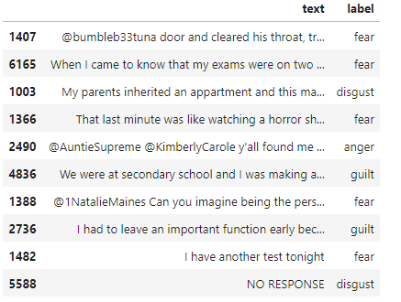

**Fig 2:** The raw dataset containing the text and emotion label column.

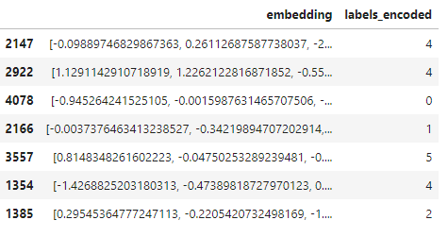

**Fig 3: The** preprocess dataset ready for training the model.

**Methods**

Once the dataset was ready, I split the data into training, validation, and testing sets in 70-15-15 ratio. The training set is used to train the CNN model, while the validation set is used to evaluate its performance during training and adjust its hyperparameters. To detect emotions from text, I created a Convolutional Neural Network (CNN) model. To create a model, an architecture of the CNN model was defined, which involves specifying the number and type of layers, such as convolutional layers, pooling layers, and fully connected layers. A ‘categorical_crossentropy’ loss function and 'rmsp’ optimizer was utilized to prevent overfitting. Additionally, combining Long Short-Term Memory (LSTM) layer with CNN can help the model learn the process sequential information, which is particularly useful for natural language processing. Please note that I applied padding to the data and adjusted the dimensions of the explanatory and response variables to fit the required input for CNN model.

**Analysis**

To ensure the reliability of our findings, a portion of the dataset will be reserved as the validation set, which will not be used for training the model. While the CNN model achieved an accuracy of nearly 89% on the training set, its performance on the validation set was poor, with only 34% accuracy. This indicated that the model was overfitting. To prevent overfitting, I added regularization parameters such as 'regularizers.l2' and bias_regularizer l2, but the results remained unchanged. However, only after adding an LSTM layer did the model's performance stabilize with an accuracy rate of 36%. A training and validation accuracy and loss chart can be shown in Fig 4 below to visualize the training model results.

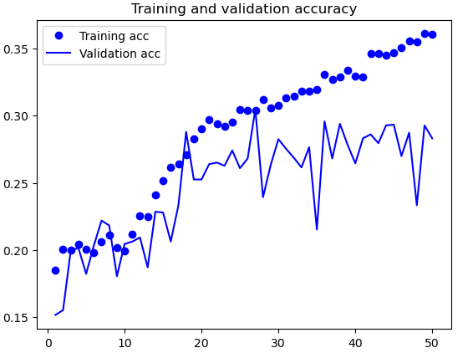

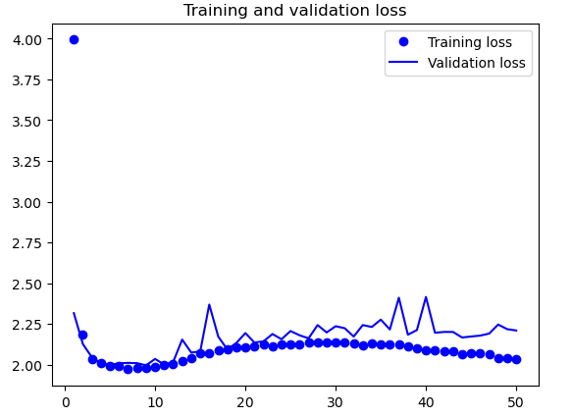

**Fig 4:** A scatterplot and line chart of both training and validation of accuracy (Top) and loss function (Bottom).

**Conclusion**

In conclusion, combining LSTM with the CNN model has successfully resolved the overfitting issue, but the challenge of improving model accuracy persists. It may be necessary to explore additional data-wrangling techniques or alternative ML/DL algorithms to enhance the model's overall accuracy. Once the model is successfully developed, it will be asked to predict emotions from manually input text containing diverse elements, such as sarcasm, misspellings, emojis, and hashtags, to validate its capabilities further. We can ensure that the model performs well across various real-world scenarios by subjecting it to varied inputs.

**Assumptions**

The only assumption that was made is that the emotion expressed in the text is conveyed through patterns of words and phrases rather than the specific meaning of individual words. The assumption may not always hold true as emotional expression can also be influenced by factors such as tone of voice, facial expressions, and body language, which cannot be captured by the text alone.

**Limitations**

The existing model can encounter several limitations. While the model was trained on straightforward text without unnecessary information or emojis, it may not accurately predict a user's sentiment when they use sarcasm or emojis to express their emotions. While there are over 27 categories of human emotions that can be expressed, the current model is limited to only 7 labeled emotions. As a result, the model may not accurately classify emotions outside of the predefined categories. Without further testing, the model trained on one dataset may not be applicable to other datasets; therefore, it cannot be generalized to new data.

**Challenges**

I encountered several issues when creating a text-based emotion recognition model. The most challenging aspect of the following project was the preprocessing stage. The survey was conducted in 37 countries; therefore, the dataset contained text in different languages. Handling large datasets with noisy text, such as emojis, typos, and misspellings, was also proven to be challenging. Since the dataset was presented in a different format, feeding the data through various preprocessing techniques, such as lemmatization, stemming, tokenization, stop-word, and then converting into 2D/3D tensor for the CNN model, has undoubtedly compromised the accuracy. Currently, the primary challenge is to identify and develop an optimized or hybrid model capable of accurately recognizing emotions from text data.

**Future Uses/Additional Applications**

Besides the text-based emotion cognition model being used in customer service, marketing, prevent cyber bullying, and health care, it can also be used in education by analyze the emotional state of students and provide personalized feedback to enhance their learning experience. This can help educators identify areas where students may be struggling and provide targeted support. Additionally, text-based emotion recognition models have potential uses in law enforcement, journalism, content moderation, and many other fields that involve text as a means of conveying information.

**Recommendations**

To improve the accuracy of the CNN model, I would like to apply Term Frequency-Inverse Document Frequency (TF-IDF) to highlight the significant terms in a text corpus. If the previous suggestion fails, I will explore the use of a Bidirectional Gated Recurrent Unit (Bi-GRU). Furthermore, I intend to experiment with other machine learning classification algorithms, including Naïve Bayes, Decision Tree, and Random Forest, with the aim of developing a robust model capable of predicting emotions from the text.

**Implementation Plan**

Currently, there are no immediate plans to deploy the model due to the substantial amount of work required to develop the model. Nevertheless, I recommend packaging the model in a suitable format, such as a Python package, to enable users to deploy and run it more efficiently within their chosen environment.

**Ethical Assessment**

While text-based emotion detection may have potential benefits in various industries, there are several ethical concerns to consider in ensuring the technology is used in a responsible manner. The most critical ethical concern to consider is privacy. People may feel an invasion of privacy since the model is trained on written communication; therefore, there is a risk of exposing sensitive information, such as political opinions, mental health issues, or personal beliefs. Technology can also be used to manipulate people by generating targeted messages intended to influence their behavior or actions. The model’s accuracy and reliability can also be questionable, especially when the model fails to account for complex human emotions such as sarcasm or irony.

**10 Questions an audience would ask you**

1. What would be the cost for deploying such technology?

2. Can text-based emotion recognition be used to detect sarcasm or irony?

3. Can text-based emotion recognition be used for real-time communication?

4. How can text-based emotion recognition be improved in the future?

5. Is there any potential bias in text-based emotion recognition technology?

6. How does text-based emotion recognition differ from other forms of emotion recognition?

7. Can text-based emotion recognition accurately distinguish between different emotions such as anger, happiness, sadness, and fear?

8. How can businesses use text-based emotion recognition to improve their customer experience?

9. Are there any regulations or standards in place to ensure responsible use of text-based emotion recognition technology?

10. How does the complexity of the dataset used to train the model impact its accuracy and effectiveness?

**Reference**

* Bharti, Santosh Kumar, et al. “Text-Based Emotion Recognition Using Deep Learning Approach.” *Computational Intelligence and Neuroscience*, U.S. National Library of Medicine, 23 Aug. 2022, <https://www.ncbi.nlm.nih.gov/pmc/articles/PMC9427219/>.
* Isokpan, Esosa, et al. “Cyberbullying Facts.” Cyberbullying Research Center, <https://cyberbullying.org/facts>.